Networking Fundamentals Report
Name: Amruta Deshmukh
Task: Task 11 - Networking Fundamentals (Day 11 of 45)
1. Objective
To build a basic network topology, understand how devices connect, assign IP addresses, and observe how data packets flow from one device to another.
2. Tools Used
- Cisco Packet Tracer
3. Practical Implementation (What I Did)
- I created a simple network topology consisting of 2 PCs (PC0 and PC1), 1 Switch, and 1 Router.
- I connected the PCs to the Switch using Straight-Through copper cables, and the Switch to the Router.
- I assigned static IPv4 addresses to both PCs within the same subnet (192.168.1.0/24).
- I accessed the Router via CLI and configured its FastEthernet0/0 interface with the gateway IP address (192.168.1.1) and enabled the port using the no shutdown command.
- Finally, I tested connectivity by running a ping command from PC0 to PC1, which was successful.
4. Screenshots
- Screenshot 1: Network Topology (Green cables showing all devices connected)
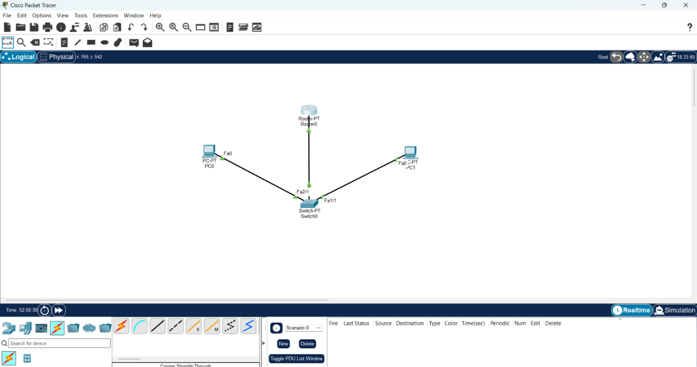
- Screenshot 2: Ping Test successful in PC0 Command Prompt (Reply from 192.168.1.11)
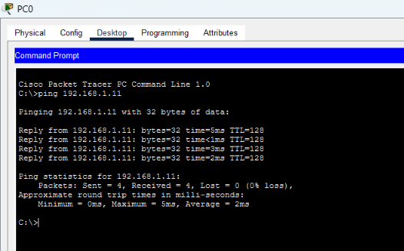
5. Interview Questions & Answers
Q1: What is an IP address?
Answer: An IP (Internet Protocol) address is a unique numerical label assigned to every device connected to a computer network. It serves two main functions: identifying the host or network interface, and providing the location of the host in the network. It operates at the Network Layer (Layer 3) and acts like a mailing address for data packets.
Q2: What is a MAC address?
Answer: A MAC (Media Access Control) address is a unique identifier assigned to a network interface controller (NIC) for use as a network address in communications within a network segment. It is a 48-bit hexadecimal address burned into the hardware by the manufacturer. It operates at the Data Link Layer (Layer 2) and acts as a physical fingerprint for the network card.
Q3: What is a port?
Answer: In networking, a port is a logical communication endpoint. While an IP address gets the data to the right computer, the port number ensures the data reaches the right application or service on that computer. Common ports include Port 80 (HTTP), Port 443 (HTTPS), and Port 22 (SSH).
6. Understanding Network Devices (Mini Guide)
- Router: Connects different networks together (like your home network to the Internet). It uses IP addresses to decide the best path to send data packets.
- Switch: Connects devices within the same local network (LAN). It uses MAC addresses to forward data only to the specific device that needs it.
- Firewall: Acts as a security guard. It monitors and controls incoming and outgoing network traffic based on predetermined security rules, blocking unauthorized access.
7. How Data Packets Flow (Summary)
When PC0 sends data to PC1, the data is broken into packets. The packet goes to the Switch, which uses the MAC address to send it locally. Since the destination is on the same network, the Switch forwards it directly to PC1. If the destination were outside the network (e.g., the Internet), the packet would go to the Router (Default Gateway), which would route it to the external network.

